Telecom Customer Segmentation
& Package Recommendation System
Business Report — Methodology, Results & Value
Dataset: Orange / BigML Telecom Churn — 3,333 subscribers • Overall churn rate 14.5%

Contents

1. Executive Summary
This project turns a raw telecom subscriber table into an actionable customer-intelligence system. We profiled 3,333 customers, engineered value and usage features, grouped customers into five business segments, built a recommendation engine that suggests a better package for each subscriber, and trained a churn-prediction model that flags at-risk customers before they leave — with an explainability layer that shows why each prediction is made.

Headline results
- Churn prediction: XGBoost achieves 0.924 ROC-AUC and 87% recall on churners (holdout test) — most leavers are caught.
- Segmentation: five clear segments; the High Risk segment (728 customers) churns at 32% while paying the highest bills ($72.80 avg) — the priority retention target.
- Recommendations: a cross-sell / upsell opportunity is flagged for ~40% of subscribers.
- Top churn drivers (SHAP): total charges, voicemail plan, international calls, and customer-service calls.

2. What Was Done
The work is organised as a reproducible 7-phase pipeline:
Phase | Activity | Output
1. EDA | Distributions, correlations, churn boxplots | 7 charts + insights
2. Feature Engineering | Total usage/charges, intl ratio, value score, segments | Enriched dataset
3. Segmentation | K-Means + DBSCAN, profiled & named clusters | 5 business segments
4. Recommendation | KNN — 5 most-similar customers per subscriber | Package per customer
5. Churn Prediction | KNN / RF / XGBoost + SMOTE + tuned CV | Best model (XGBoost)
6. Explainability | SHAP on the tuned model | Ranked churn drivers
7. Business Value | Translate analytics into operator actions | This report

3. Key Findings (EDA)
- Heavy users (top 10% by minutes) churn 47% vs 14.5% overall.
- Top payers (top 10% by charges) churn 63% — the most valuable customers are the most likely to leave.
- Customers with ≥4 service calls churn 52% — a clear distress signal.
- International-plan holders churn 42% vs 11.5% without.
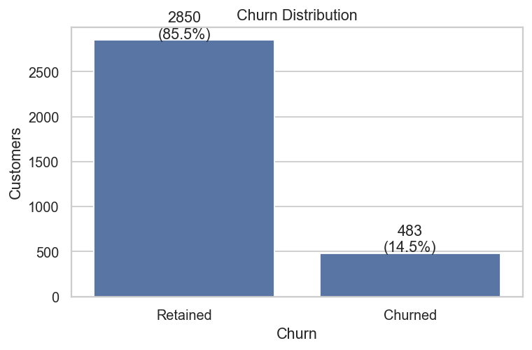
Churn distribution (14.5% of customers churn)
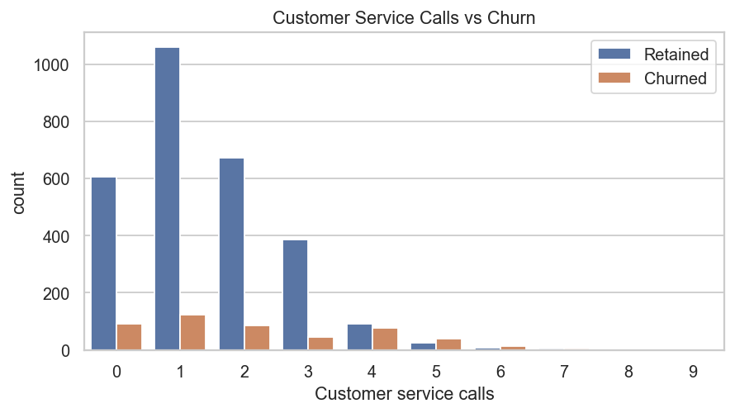
Churn rises sharply with the number of customer-service calls
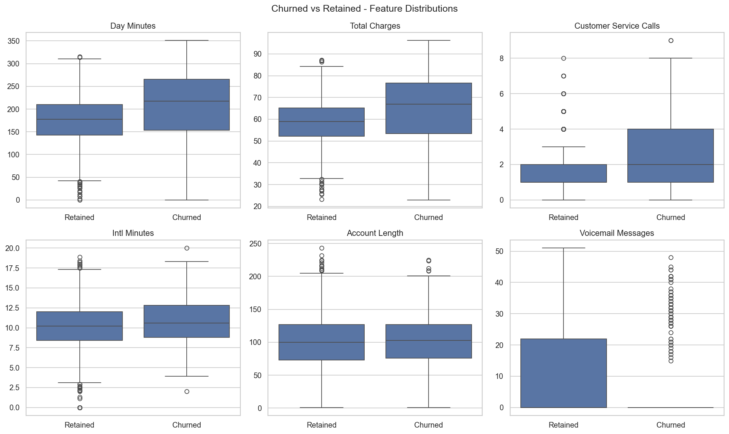
Churned vs retained customers across key features

4. Customer Segments
K-Means (with a DBSCAN cross-check) groups customers into five segments, each mapped to a business profile:
Segment | Customers | Churn | Avg Bill | Value Score
High Risk Users | 728 | 32% | $72.80 | 57.2
Premium Users | 836 | 9% | $60.10 | 46.6
Voice Heavy Users | 509 | 10% | $60.27 | 49.7
International Users | 568 | 13% | $44.97 | 34.7
Low Revenue Users | 692 | 7% | $55.91 | 43.1
The High Risk Users segment (highlighted) is the standout concern: they pay the most yet churn at 32% — protecting them protects the most revenue.
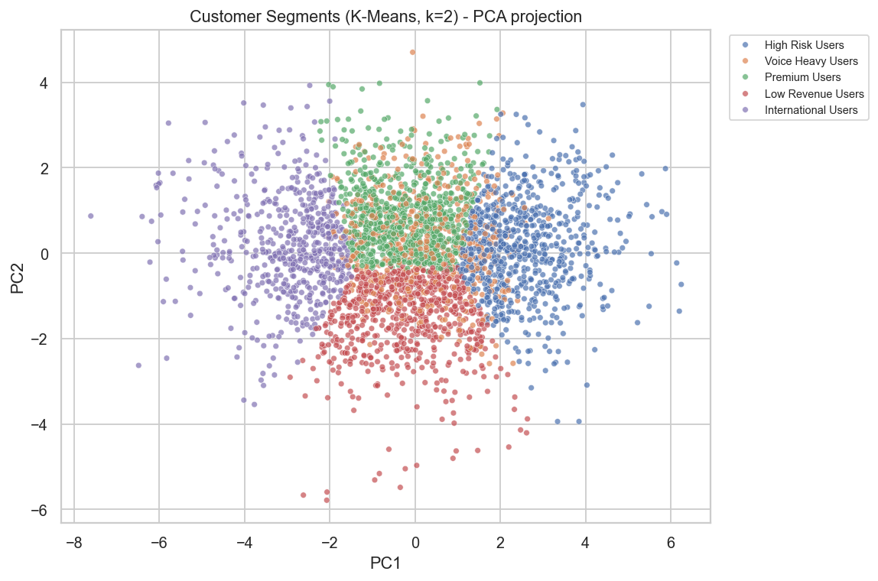
Customer segments (K-Means) — PCA projection

5. Package Recommendation Engine
For every subscriber the engine finds the 5 most similar customers — by usage, charges, international calls, tenure and service calls — and recommends the package most common among them: “Customers similar to you are using Package X.” This surfaces a cross-sell / upsell opportunity for roughly 40% of the base, and gives front-line staff a concrete next-best offer for each customer.

6. Churn Prediction Results
Three models were tuned with SMOTE (to handle the 14.5% imbalance) and Stratified 5-fold cross-validation, then scored on the untouched 20% holdout split.
Model | CV ROC-AUC | Test ROC-AUC | Test F1
KNN | 0.880 | 0.904 | 0.560
RandomForest | 0.915 | 0.920 | 0.876
XGBoost | 0.925 | 0.923 | 0.843
XGBoost is the best model: 0.924 ROC-AUC, 95% accuracy, and 87% recall on churners — it catches the large majority of customers who are about to leave.
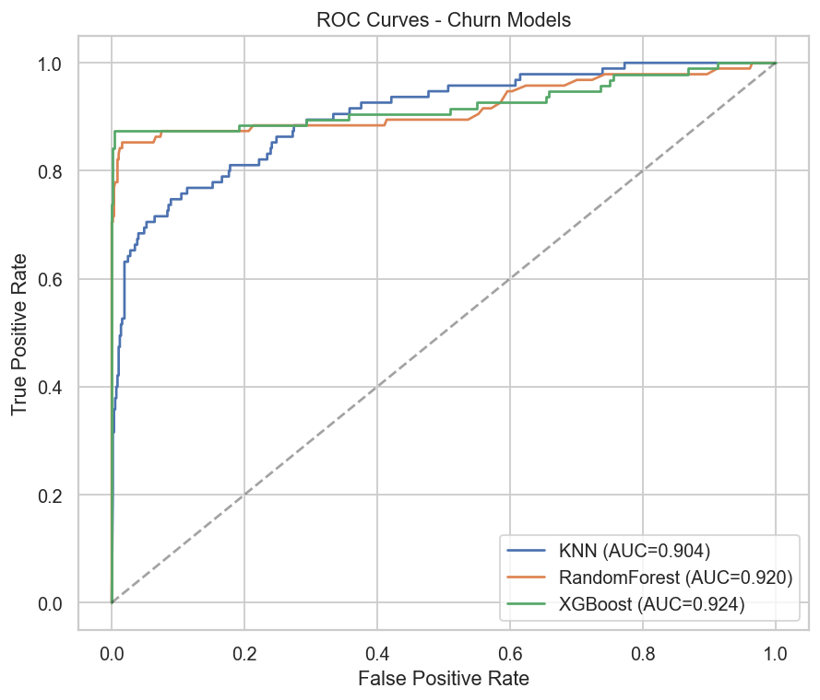
ROC curves for the three tuned models
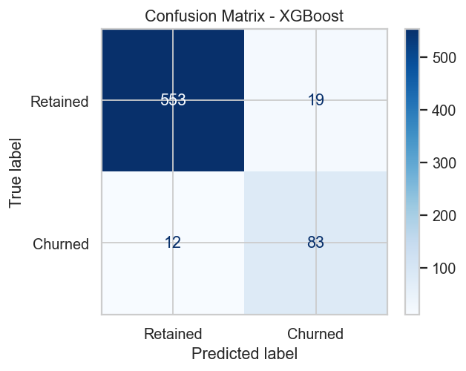
Confusion matrix — best model (XGBoost) on holdout

7. Why Customers Churn (SHAP)
SHAP explains the model's predictions. The strongest churn drivers are:
Rank | Driver | Impact (mean |SHAP|)
1 | Total Charges | 1.184
2 | Voice mail plan | 0.812
3 | Number vmail messages | 0.488
4 | Total intl calls | 0.486
5 | Customer service calls | 0.418
6 | International Usage Ratio | 0.218
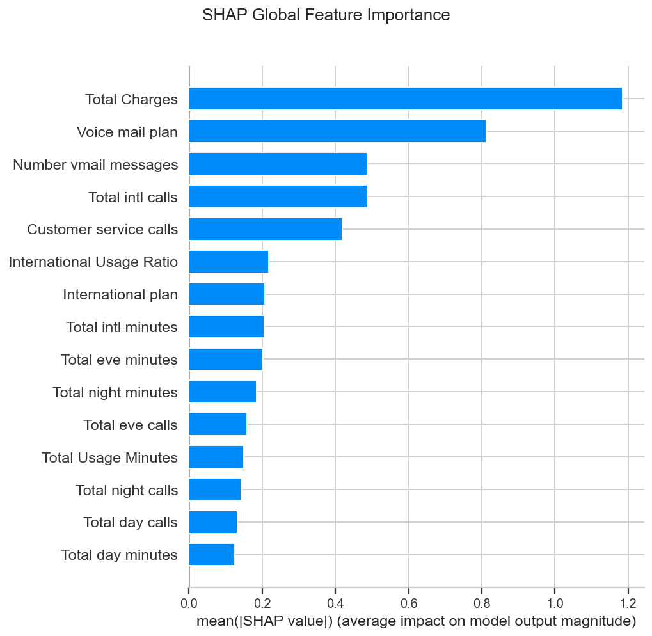
Global feature importance (mean absolute SHAP value)

8. Business Value
The pipeline converts raw subscriber data into five concrete operator capabilities:
- Identify high-value customers — the Customer Value Score and segments rank the base by worth.
- Recommend better packages — the KNN engine gives every subscriber a next-best-offer, with upsell flags.
- Reduce churn — every subscriber gets a churn probability and risk band, so retention teams act before customers leave.
- Increase ARPU — move Low-Revenue users onto fitting paid packages and upsell Premium / International users.
- Sharper retention campaigns — target the High-Risk & High-Value overlap, where saved revenue per customer is greatest.

Recommended actions
- Launch a proactive save-desk for High-Risk customers with ≥3 service calls.
- Audit the international plan — its holders churn ~4× the base; revisit pricing / quality.
- Feed the scored dataset (telecom_scored.csv) into a Power BI dashboard for ongoing monitoring.
All figures in this report are produced by the reproducible pipeline; the scored dataset is Power BI-ready.

